45th National Chemistry Olympiad

Maastricht University

PRACTICAL TEST

Assignment booklet

Thursday June 6, 2024





The experiments for this test were prepared by:
Dr. Kathia Jimenez Monroy
Richard Matysek
Joeri Noordijk
Dr. Giuditta Perversi
Dr. Erik Steen Redeker
Dr. Veaceslav Vieru

The NSO committee:
Emiel de Kleijn

The final editing was done by:
Drs. Kees Beers, drs. Dick Hennink
The exam was translated into English by:
Drs. Kees Beers, drs. Dick Hennink, drs. Jan Rombach

Directions/resources
- This practical test consists of two parts:
  - The determination of the amount of crystal water (x) in a mixture of
Na₂CO₃.xH₂O and NaHCO₃.
  - Kinetic study of the decomposition of tris-(oxalato)-manganate(III) ions.

- The practical test ends after 4 hours. During this time:
  - the attached answer sheets need to be completed;
  - all questions must be answered.

- After the practical test, when you have handed in everything, the glassware still needs to be cleaned and tidied up.

- The maximum score for the practical test is 80 points.

- The score is determined by:
  - practical skills, working clean, safety maximum 20 points
  - results of the determinations and answers to the questions maximum 60 points

- Required tools: (graphic) calculator, ruler/protractor triangle and Binas or ScienceData.

- First read the introduction and all assignments before you start working.

- Write the answers to the questions in the boxes on the answer sheets provided. If you don't have enough space, you can ask for extra paper.

Additional:
- This is a test; it is not permitted to consult with other participants.
- If you have a question, you can ask the supervisor.
- If something is wrong with your glassware or equipment, report it to the supervisor as soon as you discover it. Don't borrow someone else's things!

- The determination of the amount of crystal water (x) in a mixture of Na₂CO₃.xH₂O and NaHCO₃ 40 points
Introduction
Sodium carbonate is mined mostly from a mineral named Trona. It is a mixture of hydrated sodium carbonate (Na₂CO₃.xH₂O) and sodium hydrogen carbonate (NaHCO₃).
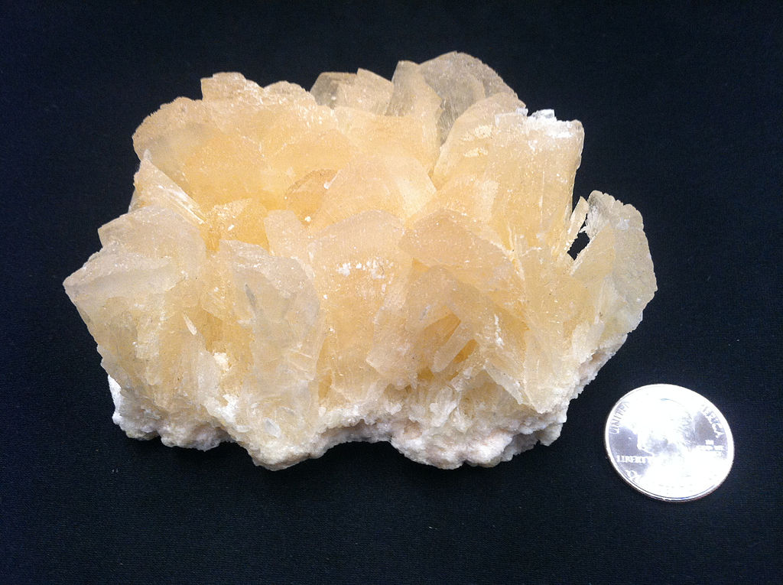

The goal of this task is to determine the amount of crystal water bound to sodium carbonate in a solid mixture containing hydrated sodium carbonate (Na₂CO₃.xH₂O) and sodium hydrogen carbonate (NaHCO₃).
In this determination two separate titrations with a solution of hydrochloric acid are performed:
- a titration with methyl orange as the indicator
- a titration with phenolphthalein as the indicator.
Each titration is executed in duplicate. In advance, you have to execute a test titration.
Chemicals
- a weighed mixture of Na₂CO₃.xH₂O and NaHCO₃
- 0.1000 M hydrochloric acid
- a solution of methyl orange
- a solution of phenolphthalein
- demineralized water
Safety
- wear safety glasses
- if your skin comes into contact with any of the chemicals, rinse it immediately
Equipment and glassware
- 250 mL volumetric flask
- funnel for the volumetric flask
- 50 mL burette
- funnel for the burette
- four beakers
- four small plastic pipettes
- pipette-balloon
- 25 mL pipette
- 50 mL Erlenmeyer flask for the titrations
- marker
- magnetic stirrer
- magnetic stir bar
Procedure
- Prepare a solution of your solid sample in the 250 mL volumetric flask.
- Fill the burette with the 0.1000 M hydrochloric acid.
Note: Probably you have to refill the burette a few times during the determination.
- With each of the titrations below, first perform a test titration. Afterwards perform each titration in duplicate.
Titration in presence of phenolphthalein
- Add 25.00 mL of the solution that is in the volumetric flask to the 50 mL Erlenmeyer flask.
- Add three drops of the phenolphthalein solution.
- Put the magnetic stir bar in the solution and start stirring (don’t heat).
- Titrate until the pink colour disappears totally.
- Repeat steps 4 to 7.
Titration in presence of methyl orange
- Add 25.00 mL of the solution that is in the volumetric flask, to the 50 mL Erlenmeyer flask.
- Add three drops of the methyl orange solution.
- Titrate until the colour becomes red.
- Repeat steps 9 to 11.

Questions – write the answers on the answer sheets
- Write down:
  - the mass of the sample
  - the molarity of the hydrochloric acid
  - all burette readings 8
- Give the equations of the reactions that occur during the titrations. 4
- Calculate the amount of mmoles of Na₂CO₃.xH₂O and the amount of mmoles of NaHCO₃ in your sample. 10
- Calculate the value of x in Na₂CO₃.xH₂O. 4
- It is also possible to perform the determination by using a precipitation reaction (and weighing the precipitate) instead of one of the titrations.
Explain which solution could be used and which titration does not have to be executed in that case. 4
- Kinetic study of the decomposition of tris-(oxalato)-manganate(III) ion 40 points
Introduction
When solutions of manganese(II) sulfate, potassium permanganate and oxalic acid are poured together, so called tris-(oxalato)-manganate(III) ions, {Mn(C₂O₄)₃}³⁻ are formed according the reaction equation below:
MnO₄⁻ + 4 Mn²⁺ + 15 H₂C₂O₄ → 5 {Mn(C₂O₄)₃}³⁻ + 22 H⁺ + 4 H₂O reaction 1
As soon as these ions are formed, they begin to decompose and Mn²⁺, C₂O₄²⁻ and CO₂ are formed:
2 {Mn(C₂O₄)₃}³⁻ → 2 Mn²⁺ + 5 C₂O₄²⁻ + 2 CO₂ reaction 2
The rate equation of reaction 2 can be given as:
The goal of this experiment is:
- to show that reaction 2 is a first order reaction;
- to determine the value of the rate constant k.
Because the ions {Mn(C₂O₄)₃}³⁻ give the solution a light brown colour (λ_{max} = 440 nm) and the reaction products are colourless, the course of the reaction can be followed spectrophotometrically by measuring regularly the absorbance (extinction) A of the solution.
The average reaction rate in a time interval Δt can be calculated by using the expression below:
In this expression ΔA is the change in the absorbance (extinction) in the time interval Δt and is [{Mn(C₂O₄)₃}³⁻] the concentration of the complex at the beginning of that time interval.
Further applies that ε = 70 L mol⁻¹ cm⁻¹ and l = 1.00 cm.
The experiment is executed in two variants, with two sets of solutions that differ in concentration.
To execute the measurements with the spectrophotometer you can get help from the lab assistant.
Chemicals
- solutions of MnSO₄: 0.20 M and 0.075 M
- solutions of H₂C₂O₄: 0.20 M and 0.075 M
- solutions of KMnO₄: 0.020 M and 0.0075 M
Safety
- wear safety glasses
- if your skin comes into contact with any of the chemicals, rinse it immediately.
Materials
- a 2 mL pipette
- a 10 mL pipette
- a 25 mL pipette
- three plastic pipettes
- three UV cuvettes
- pipette-balloon
- two 50 mL Erlenmeyer flasks
- four beakers
- magnetic stirrer
- magnetic stir bar
- stopwatch
Procedure
Variant I
- Introduce successively into the 50 mL Erlenmeyer flask: 2.0 mL of 0.20 M solution of MnSO₄ and 14.0 mL of 0.20 M solution of H₂C₂O₄.
- Put the magnetic stir bar into the solution and start stirring (don’t heat).
- Add 4.0 mL 0.020 M solution of KMnO₄ and start timing.
- Immediately after starting timing, take a sample from the reaction vessel with the plastic pipette, bring it into a cuvette and measure the absorbance .
- Write down, in the designated table of your answer sheet, the measured absorbance and the time of the measurement.
- Pour back the solution from the cuvette into the reaction vessel.
- After about 60 s, take another sample from the solution and measure the absorbance. Write down, in the table of your answer sheet, the absorbance and the time of the measurement.
- Pour back the solution from the cuvette into the reaction vessel.
- Repeat steps 7 and 8 three times approximately every 60 s.
Variant II
- Repeat steps 1 to 7 of the procedure of variant I, but now use 0.075 M solution of MnSO₄, 0.075 M solution of H₂C₂O₄ and 0.0075 M solution of KMnO₄.

Questions – write the answers on the answer sheets
- Write down, in the designated tables of your answer sheet, all measured absorbances and the times of the measurements of the absorbances. 2
- Calculate the reaction rate in the first time interval for both variants.
Write down your calculation in the designated tables of your answer sheet. 2
The order of the reaction can be calculated by means of the formula below:
In this formula s_{I} and s_{II} are the reaction rates in the first time interval of variant I and variant II, respectively. [{Mn(C₂O₄)₃}³⁻] _{I} and [{Mn(C₂O₄)₃}³⁻] _{II} are the initial concentrations of the complex ion in the first time interval of both variants. These approximately equal the concentrations of the complex ion on t = 0: [{Mn(C₂O₄)₃}³⁻] _{I} = 0.020 mol L⁻¹ and [{Mn(C₂O₄)₃}³⁻] _{II} = 0.0075 mol L⁻¹.
- Calculate n using your measurements. 8
- Does it follow from your measurements that reaction 2 is a first order reaction? Motivate your answer. 2
- Calculate the reaction rates in the second, third and fourth time interval of variant I. Write down your calculations in the designated table of your answer sheet. 3
- Calculate the average rate constant k that follows from this, assuming that reaction 2 is a first order reaction.
Write down your calculations in the designated table of your answer sheet. 9
- Show, by means of a calculation, that the initial concentration of {Mn(C₂O₄)₃}³⁻ in variant I equals 0.020 mol L⁻¹. 4

